Reports.

# Tax Report 1

## Format

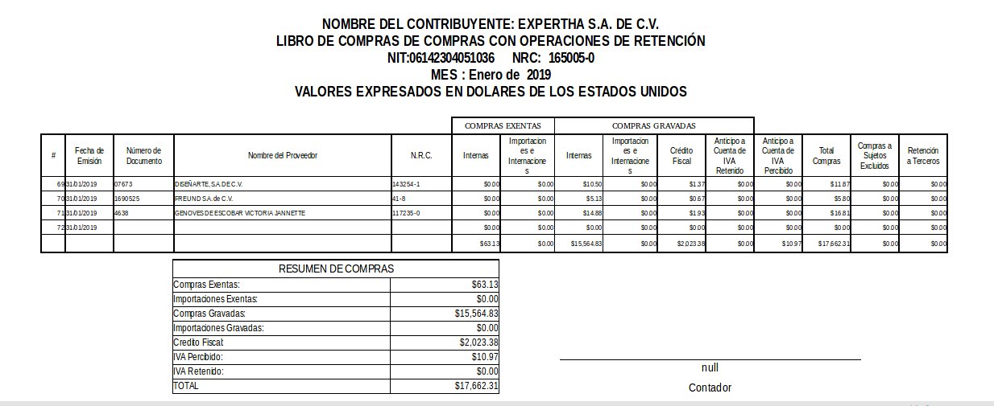

## SQL Query-Header

select c.name as Compania

,c.sv_nit as NIT

,c.sv_nrc as NRC

,sv_revisa_partida as Contador

from res_company c

where c.id= $P{companyId}

## SQL Query-Detail

select * from (

select ai.date_invoice as fecha

,ai.reference as factura

,rp.name as proveedor

,rp.vat as NRC

,case

when rp.country_id=211 then False

when rp.country_id is null then False

else True end as Importacion

,/*Calculando el gravado (todo lo que tiene un impuesto aplicado de iva)*/

(select coalesce(sum(price_subtotal_signed),0.00)

from account_invoice_line ail

where invoice_id=ai.id

and exists(select ailt.tax_id

from account_invoice_line_tax ailt

inner join account_tax atx on ailt.tax_id=atx.id

inner join account_tax_group atg on atx.tax_group_id=atg.id

where ailt.invoice_line_id=ail.id and atg.name='iva')

) as Gravado,

/*Calculando el excento que no tiene iva*/

(Select coalesce(sum(price_subtotal_signed),0.00)

from account_invoice_line ail

where invoice_id=ai.id

and not exists(select ailt.tax_id

from account_invoice_line_tax ailt

inner join account_tax atx on ailt.tax_id=atx.id

inner join account_tax_group atg on atx.tax_group_id=atg.id

where ailt.invoice_line_id=ail.id and atg.name='iva')

) as Exento

,/*Calculando el iva*/

(Select coalesce(sum(ait.amount),0.00)

from account_invoice_tax ait

inner join account_tax atx on ait.tax_id=atx.id

inner join account_tax_group atg on atx.tax_group_id=atg.id

where invoice_id=ai.id

and atg.name='iva'

) as Iva

,/*Calculando el retenido*/

(Select coalesce(sum(ait.amount),0.00)

from account_invoice_tax ait

inner join account_tax atx on ait.tax_id=atx.id

inner join account_tax_group atg on atx.tax_group_id=atg.id

where invoice_id=ai.id

and atg.name='retencion'

) as Retenido

,/*Calculando el percibido*/

(Select coalesce(sum(ait.amount),0.00)

from account_invoice_tax ait

inner join account_tax atx on ait.tax_id=atx.id

inner join account_tax_group atg on atx.tax_group_id=atg.id

where invoice_id=ai.id

and atg.name='percepcion'

) as Percibido

,/*Calculando el excluido*/

(Select coalesce(sum(ait.amount),0.00)

from account_invoice_tax ait

inner join account_tax atx on ait.tax_id=atx.id

inner join account_tax_group atg on atx.tax_group_id=atg.id

where invoice_id=ai.id

and atg.name='excluido'

) as Excluido

,/*Calculando el retencion a terceros*/

(Select coalesce(sum(ait.amount),0.00)

from account_invoice_tax ait

inner join account_tax atx on ait.tax_id=atx.id

inner join account_tax_group atg on atx.tax_group_id=atg.id

where invoice_id=ai.id

and atg.name='retencion3'

) as retencion3

from account_invoice ai

inner join res_partner rp on ai.partner_id=rp.id

where ai.company_id= $P{companyId}

and date_part('year',COALESCE(ai.sv_fecha_tax,ai.date_invoice))= $P{year}

and date_part('month',COALESCE(ai.sv_fecha_tax,ai.date_invoice))= $P{month}

and ai.type='in_invoice'

and ((ai.sv_no_tax is null ) or (ai.sv_no_tax=false))

and ai.state in ('open','paid')

and ((ai.sv_importacion_number is null) or (trim(ai.sv_importacion_number)=''))

union all

select min(SI.fecha) as fecha

,SI.sv_importacion_number as factura

,'DGT' as proveedor

,'DGT' as NRC

,True as Importacion

,sum (SI.Gravado) as Gravado

,sum (SI.Exento) as Exento

,sum (SI.Iva) as Iva

,sum (SI.Retenido) as Retenido

,sum (SI.Percibido) as Percibido

,sum (SI.Excluido) as Excluido

,sum (SI.retencion3) as retencion3

from (

select ai.date_invoice as fecha

,ai.reference as factura

,ai.sv_importacion_number

,rp.name as proveedor

,rp.vat as NRC

,case

when rp.country_id=211 then False

when rp.country_id is null then False

else True end as Importacion

,/*Calculando el gravado (todo lo que tiene un impuesto aplicado de iva)*/

(select coalesce(sum(price_subtotal_signed),0.00)

from account_invoice_line ail

where invoice_id=ai.id

and exists(select ailt.tax_id

from account_invoice_line_tax ailt

inner join account_tax atx on ailt.tax_id=atx.id

inner join account_tax_group atg on atx.tax_group_id=atg.id

where ailt.invoice_line_id=ail.id and atg.name='iva')

) as Gravado,

/*Calculando el excento que no tiene iva*/

(Select coalesce(sum(price_subtotal_signed),0.00)

from account_invoice_line ail

where invoice_id=ai.id

and not exists(select ailt.tax_id

from account_invoice_line_tax ailt

inner join account_tax atx on ailt.tax_id=atx.id

inner join account_tax_group atg on atx.tax_group_id=atg.id

where ailt.invoice_line_id=ail.id and atg.name='iva')

) as Exento

,/*Calculando el iva*/

(Select coalesce(sum(ait.amount),0.00)

from account_invoice_tax ait

inner join account_tax atx on ait.tax_id=atx.id

inner join account_tax_group atg on atx.tax_group_id=atg.id

where invoice_id=ai.id

and atg.name='iva'

) as Iva

,/*Calculando el retenido*/

(Select coalesce(sum(ait.amount),0.00)

from account_invoice_tax ait

inner join account_tax atx on ait.tax_id=atx.id

inner join account_tax_group atg on atx.tax_group_id=atg.id

where invoice_id=ai.id

and atg.name='retencion'

) as Retenido

,/*Calculando el percibido*/

(Select coalesce(sum(ait.amount),0.00)

from account_invoice_tax ait

inner join account_tax atx on ait.tax_id=atx.id

inner join account_tax_group atg on atx.tax_group_id=atg.id

where invoice_id=ai.id

and atg.name='percepcion'

) as Percibido

,/*Calculando el excluido*/

(Select coalesce(sum(ait.amount),0.00)

from account_invoice_tax ait

inner join account_tax atx on ait.tax_id=atx.id

inner join account_tax_group atg on atx.tax_group_id=atg.id

where invoice_id=ai.id

and atg.name='excluido'

) as Excluido

,/*Calculando el retencion a terceros*/

(Select coalesce(sum(ait.amount),0.00)

from account_invoice_tax ait

inner join account_tax atx on ait.tax_id=atx.id

inner join account_tax_group atg on atx.tax_group_id=atg.id

where invoice_id=ai.id

and atg.name='retencion3'

) as retencion3

from account_invoice ai

inner join res_partner rp on ai.partner_id=rp.id

where ai.company_id= $P{companyId}

and date_part('year',COALESCE(ai.sv_fecha_tax,ai.date_invoice))= $P{year}

and date_part('month',COALESCE(ai.sv_fecha_tax,ai.date_invoice))= $P{month}

and ai.type='in_invoice'

and ((ai.sv_no_tax is null ) or (ai.sv_no_tax=false))

and ai.state in ('open','paid')

and ((ai.sv_importacion_number is not null) or (trim(ai.sv_importacion_number)!=''))

) SI

group by SI.sv_importacion_number

union all

select aml.date as fecha

,am.ref as factura

,rp.name as proveedor

,rp.vat as NRC

,False as Importacion

,0.0 as Gravado

,0.0 as Exento

,0.0 as Iva

,0.0 as Retenido

,aml.debit as Percibido

,0.0 as Excluido

,0.0 as retencion3

from account_move_line aml

inner join account_move am on aml.move_id=am.id

inner join account_tax at on aml.account_id=at.account_id

inner join account_tax_group atg on at.tax_group_id=atg.id

left join res_partner rp on aml.partner_id=rp.id

where atg.name='percepcion' and not exists (select id from account_invoice ai where ai.move_id=am.id and ai.company_id= $P{companyId} )

and date_part('year',am.date)= $P{year}

and date_part('month',am.date)= $P{month}

and am.company_id= $P{companyId}

and am.state='posted'

) S

order by s.Fecha, s.Factura

# TAX Report 2

## Format

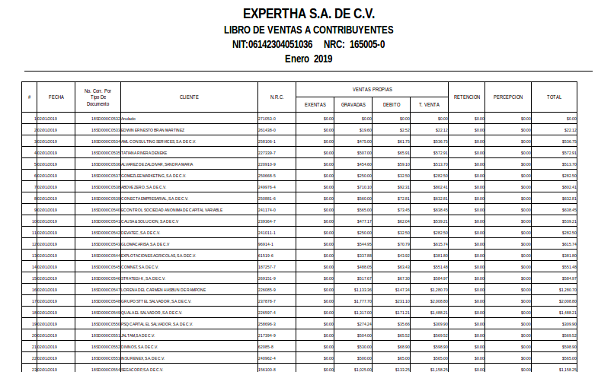

## SQL Query-Header

select c.name as Compania

,c.sv_nit as NIT

,c.sv_nrc as NRC

,c.sv_revisa_partida as Contador

from res_company c

where c.id= $P{companyId}

## SQL Query-Detail

select * from(

select ai.date_invoice as fecha

,ai.reference as factura

,rp.name as cliente

,rp.vat as NRC

,ai.state as estado

,/*Calculando el gravado (todo lo que tiene un impuesto aplicado de iva)*/

(select coalesce(sum(price_subtotal_signed),0.00)

from account_invoice_line ail

where invoice_id=ai.id

and exists(select ailt.tax_id

from account_invoice_line_tax ailt

inner join account_tax atx on ailt.tax_id=atx.id

inner join account_tax_group atg on atx.tax_group_id=atg.id

where ailt.invoice_line_id=ail.id and atg.name='iva')

) as Gravado,

/*Calculando el excento que no tiene iva*/

(Select coalesce(sum(price_subtotal_signed),0.00)

from account_invoice_line ail

where invoice_id=ai.id

and not exists(select ailt.tax_id

from account_invoice_line_tax ailt

inner join account_tax atx on ailt.tax_id=atx.id

inner join account_tax_group atg on atx.tax_group_id=atg.id

where ailt.invoice_line_id=ail.id and atg.name='iva')

) as Exento

,/*Calculando el iva*/

(Select coalesce(sum(ait.amount),0.00)

from account_invoice_tax ait

inner join account_tax atx on ait.tax_id=atx.id

inner join account_tax_group atg on atx.tax_group_id=atg.id

where invoice_id=ai.id

and atg.name='iva'

)*(case when ai.type='out_refund' then -1 else 1 end) as Iva

,/*Calculando el retenido*/

(Select coalesce(sum(ait.amount),0.00)

from account_invoice_tax ait

inner join account_tax atx on ait.tax_id=atx.id

inner join account_tax_group atg on atx.tax_group_id=atg.id

where invoice_id=ai.id

and atg.name='retencion'

) as Retenido

,/*Calculando el percibido*/

(Select coalesce(sum(ait.amount),0.00)

from account_invoice_tax ait

inner join account_tax atx on ait.tax_id=atx.id

inner join account_tax_group atg on atx.tax_group_id=atg.id

where invoice_id=ai.id

and atg.name='percepcion'

) as Percibido

from account_invoice ai

inner join res_partner rp on ai.partner_id=rp.id

left join account_fiscal_position afp on ai.fiscal_position_id=afp.id

where ai.company_id= $P{companyId}

and date_part('year',COALESCE(ai.sv_fecha_tax,ai.date_invoice))= $P{year}

and date_part('month',COALESCE(ai.sv_fecha_tax,ai.date_invoice))= $P{month}

and ((ai.type='out_invoice') or (ai.type='out_refund'))

and ((ai.sv_no_tax is null ) or (ai.sv_no_tax=false))

and afp.sv_contribuyente=True

and ai.state in ('open','paid')

union

select ai.date_invoice as fecha

,ai.reference as factura

,'Anulado' as cliente

,rp.vat as NRC

,ai.state as estado

,0.0 as Gravado

,0.0 as Exento

,0.0 as Iva

,0.0 as Retenido

,0.0 as Percibido

from account_invoice ai

inner join res_partner rp on ai.partner_id=rp.id

left join account_fiscal_position afp on ai.fiscal_position_id=afp.id

where ai.company_id= $P{companyId}

and date_part('year',COALESCE(ai.sv_fecha_tax,ai.date_invoice))= $P{year}

and date_part('month',COALESCE(ai.sv_fecha_tax,ai.date_invoice))= $P{month}

and ai.type='out_invoice'

and ((ai.sv_no_tax is null ) or (ai.sv_no_tax=false))

and afp.sv_contribuyente=True

and ai.state in ('cancel')

)S

order by s.fecha, s.factura

# TAX Report 3

Format

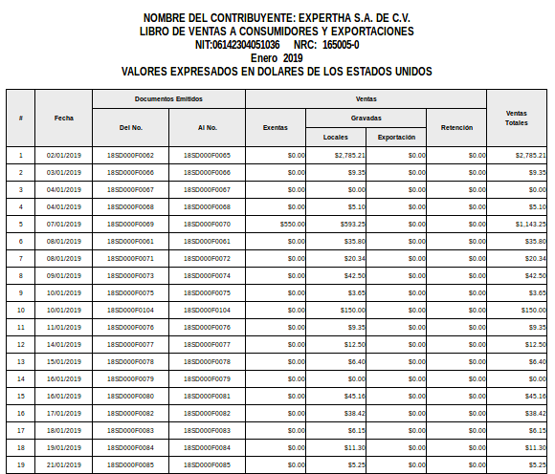

## SQL Query-Header

select c.name as Compania

,c.sv_nit as NIT

,c.sv_nrc as NRC

,c.sv_invoice_serie_size as Serie

,sv_revisa_partida as Contador

from res_company c

where c.id= $P{companyId}

## SQL Query-Detail

--select * from res_company

Select

SS.Fecha

,SS.grupo

,min(SS.Factura) as DELNum

,max(SS.Factura) as ALNum

,sum(SS.exento) as Exento

,sum(SS.GravadoLocal) as GravadoLocal

,sum(SS.GravadoExportacion) as GravadoExportacion

,Sum(SS.ivaLocal) as IvaLocal

,Sum(SS.ivaexportacion) as IvaExportacion

,Sum(SS.retenido) as Retenido

,estado

FROM (

select S.fecha

,S.factura

,S.estado

,S.grupo

,S.exento

,case

when S.sv_region='Local' then S.Gravado

else 0.00 end as GravadoLocal

,case

when S.sv_region!='Local' then S.Gravado

else 0.00 end as GravadoExportacion

,case

when S.sv_region='Local' then S.Iva

else 0.00 end as IvaLocal

,case

when S.sv_region!='Local' then S.Iva

else 0.00 end as IvaExportacion

,S.Retenido

from(

select ai.date_invoice as fecha

,coalesce(ai.reference,ai.number) as factura

,'valid' as estado

,FG.grupo

,afp.sv_region

,/*Calculando el gravado (todo lo que tiene un impuesto aplicado de iva)*/

(select coalesce(sum(price_subtotal_signed),0.00)

from account_invoice_line ail

where invoice_id=ai.id

and exists(select ailt.tax_id

from account_invoice_line_tax ailt

inner join account_tax atx on ailt.tax_id=atx.id

inner join account_tax_group atg on atx.tax_group_id=atg.id

where ailt.invoice_line_id=ail.id and atg.name='iva')

) as Gravado,

/*Calculando el excento que no tiene iva*/

(Select coalesce(sum(price_subtotal_signed),0.00)

from account_invoice_line ail

where invoice_id=ai.id

and not exists(select ailt.tax_id

from account_invoice_line_tax ailt

inner join account_tax atx on ailt.tax_id=atx.id

inner join account_tax_group atg on atx.tax_group_id=atg.id

where ailt.invoice_line_id=ail.id and atg.name='iva')

) as Exento

,/*Calculando el iva*/

(Select coalesce(sum(ait.amount),0.00)

from account_invoice_tax ait

inner join account_tax atx on ait.tax_id=atx.id

inner join account_tax_group atg on atx.tax_group_id=atg.id

where invoice_id=ai.id

and atg.name='iva'

) as Iva

,/*Calculando el retenido*/

(Select coalesce(sum(ait.amount),0.00)

from account_invoice_tax ait

inner join account_tax atx on ait.tax_id=atx.id

inner join account_tax_group atg on atx.tax_group_id=atg.id

where invoice_id=ai.id

and atg.name='retencion'

) as Retenido

from account_invoice ai

inner join res_partner rp on ai.partner_id=rp.id

inner join (select * from FacturasAgrupadas( $P{companyId}, $P{month} , $P{year} , $P{serie} )) FG on ai.id=FG.invoice_id

left join account_fiscal_position afp on ai.fiscal_position_id=afp.id

where ai.company_id= $P{companyId}

and date_part('year',COALESCE(ai.sv_fecha_tax,ai.date_invoice))= $P{year}

and date_part('month',COALESCE(ai.sv_fecha_tax,ai.date_invoice))= $P{month}

and ai.type='out_invoice'

and ((ai.sv_no_tax is null ) or (ai.sv_no_tax=false))

and afp.sv_contribuyente=False

and ai.state in ('open','paid')

union

select ai.date_invoice as fecha

,coalesce(ai.reference,ai.number) as factura

,ai.state as estado

,FG.grupo

,afp.sv_region

,0.0 as Gravado

,0.0 as Exento

,0.0 as Iva

,0.0 as Retenido

from account_invoice ai

inner join res_partner rp on ai.partner_id=rp.id

inner join (select * from FacturasAgrupadas( $P{companyId} , $P{month}, $P{year} , $P{serie})) FG on ai.id=FG.invoice_id

left join account_fiscal_position afp on ai.fiscal_position_id=afp.id

where ai.company_id= $P{companyId}

and date_part('year',COALESCE(ai.sv_fecha_tax,ai.date_invoice))= $P{year}

and date_part('month',COALESCE(ai.sv_fecha_tax,ai.date_invoice))= $P{month}

and ai.type='out_invoice'

and ((ai.sv_no_tax is null ) or (ai.sv_no_tax=false))

and afp.sv_contribuyente=False

and ai.state in ('cancel')

)S

)SS

group by SS.fecha, SS.Grupo,SS.estado

order by SS.fecha, SS.Grupo

## FUNCTION **facturasagrupadas**. Required by SQL QUERY-Detail

CREATE OR REPLACE FUNCTION public.facturasagrupadas(p_company_id integer, month_number integer, year_number integer, p_series_lenght integer)

RETURNS TABLE(invoice_id integer, factura_number character varying, factura_status character varying, grupo integer)

LANGUAGE plpgsql

AS $function$

DECLARE

var_r record;

var_serie varchar;

var_fecha date;

var_correlativo int;

var_estado varchar;

var_grupo int;

BEGIN

var_grupo :=0;

FOR var_r IN (select ROW_NUMBER () OVER (ORDER BY f.date_invoice,coalesce(F.reference,F.number)) as Registro

,left(coalesce(F.reference,F.number),p_series_lenght) as Serie

,cast(right(coalesce(F.reference,F.number),(length(coalesce(F.reference,F.number))-p_series_lenght)) as Integer) as correlativo

,F.date_invoice as fecha

,case

when F.state='cancel' then 'ANULADA'

else 'Valida' end as estado

,coalesce(F.reference,F.number) as factura,F.id

from Account_invoice F

inner join account_fiscal_position afp on F.fiscal_position_id=afp.id

where date_part('year',COALESCE(F.sv_fecha_tax,F.date_invoice))= year_number

and date_part('month',COALESCE(F.sv_fecha_tax,F.date_invoice))= month_number

and F.state<>'draft' and F.company_id=p_company_id

and F.type in ('out_invoice')

and ((F.sv_no_tax is null ) or (F.sv_no_tax=false))

and afp.sv_contribuyente=False

order by fecha,factura )

LOOP

invoice_id := var_r.id;

factura_number := var_r.Factura;

factura_status := var_r.estado;

if ((var_r.Serie=var_serie) and (var_r.fecha=var_Fecha) and (var_r.estado=var_estado) and (var_r.correlativo=(var_correlativo+1))) then

grupo := var_grupo;

else

var_grupo := var_grupo+1;

grupo := var_grupo;

end if;

var_serie := var_r.Serie;

var_fecha := var_r.fecha;

var_estado := var_r.estado;

var_correlativo := var_r.correlativo;

RETURN NEXT;

END LOOP;

END;

$function$

;